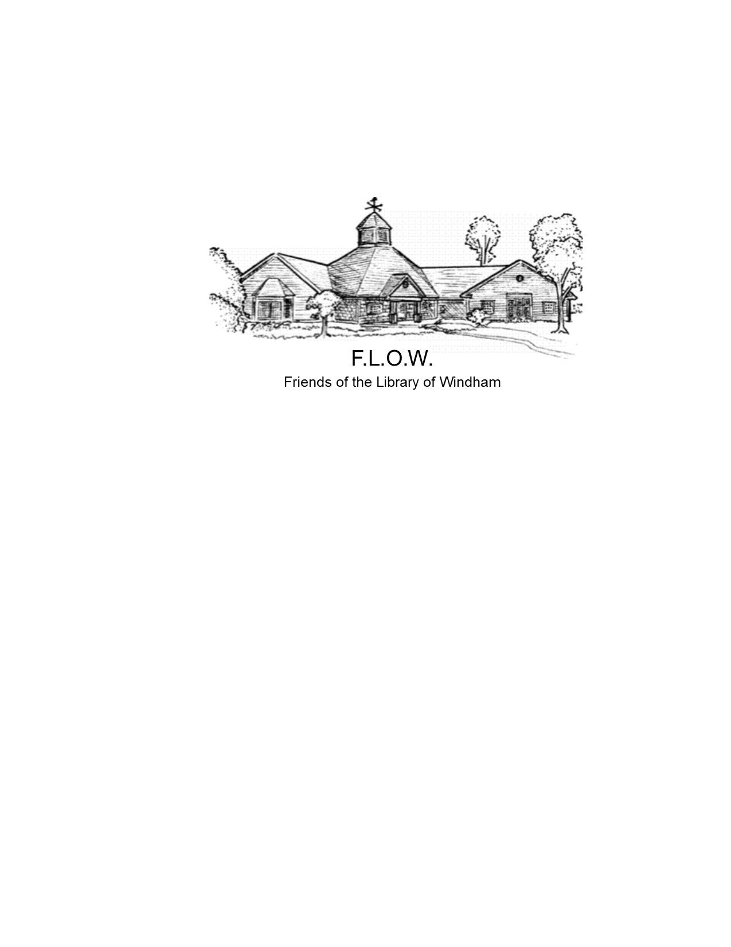

The Friends of the Library of Windham (FLOW) is pleased to announce that it will be awarding three distinct academic grants for a total amount of $6,500; two are for high school seniors working toward a 4 year degree at a college or university and one is for a high school senior going to a community college or trade school.

The recipients of the 2025 FLOW Academic Grants will be awarded funds to use toward tuition, the purchase of books, and any other supplies needed to further their education. This is a one-time award, not an annual recurring one. Scholars may only receive it once. Academic Grant winners will be recognized at the Windham High School Blue and Gold Award Ceremony.

Applications are available at the Nesmith Library, FLOW’s website, and on the Windham High School’s scholarship portal. Please complete all the required steps carefully and return it either to the Windham High School Guidance Office or to the library by the end of day on **Friday, March 14th** (no late applications will be accepted).

Application Process

* Type all information on the application. Handwritten applications will not be accepted
* Complete Application form (this must be included with your application) Page 2
* Required essay Page 3
* Description of each academic grant and its relevant requirements
  + The Mary Long Arts Grant ($2,500) Page 4
  + The Professional Studies Grant ($2,500) Page 5
  + The Community College/Trade School Grant ($1,500) Page 6
* List of or information about your extracurricular activities or work experience…….Page 10
* In addition to the forms, documents, essay and extracurricular activity/ activities list, applicants who are finalists for each academic grant will be invited to a personal interview if the selection process is competitive.

If you have any questions or concerns, please email [AcademicGrants@FlowWindham.org](mailto:Scholarships@FlowWindham.org).

# Friends of the Library of Windham

# Academic grant 2025

# Application Form

Type your answers.

Please indicate which academic grant you are applying for:

* The Mary Long Arts Grant

# The Professional Studies Grant

* The Community College/Trade School Grant

Applicant’s Name:

Address:

Email:

Phone Number:

High School: GPA:

College Acceptance:

Intended Major:

Essay

Please write a short essay (300-500 words) that describes who you are. The essay can focus on any specific topic you like (such as sports, outside activities, community action, academics, a person who has made a big impact on your life, religion, etc.), but must address the following:

* What is your passion in life and how does that fit with your professional goals?
* How do you plan to get there?
* What have you done in or out of school that addresses your passion?
* How is secondary education going to feed that passion?
* Why do you deserve this academic grant money?

***Your essay must be typed. Do not submit a handwritten essay.***

The essay will be evaluated on the following: (scoring rubric attached)

* Clarity (how well you have expressed your passion)
* Realistic goals (how attainable your goals appear)
* Quality of writing (good grammar, sensible transitions, spell-checked)
* Coherence (Does your essay make sense? Do your goals and passions comport with your activities and argument for getting the award?)

Requirements for the Mary Long Arts Grant

### The Mary Long Arts Grant is established to help students pursue their studies in the arts. Examples of degrees may include:

|  |  |  |  |
| --- | --- | --- | --- |
| Architecture  Art  Art Conservation  Art History | Broadcast Journalism  Communications  Creative Writing  Dance | Drama/Theatre  Music  Film  Graphic Arts | Web Design  Museum Studies |

**Minimum Requirements for this academic grant**

* Acceptance to a 4-year accredited university or college in one of the above programs
* Windham Resident
* Grade point average of 3.0 or higher
* Graduating Senior

**Required documentation**

Each of these items must accompany the application. If any items are missing, the application will be disqualified.



* The application form must be included with the application
* Copy of acceptance letter from university or college
* Official transcript from your high school in a sealed envelope with the school seal
* Three letters of reference which need to be numbered according to whom they are from. Please make sure that the reference contact information is on the letters, in case we need to contact them. (Please do not use your college application letter as a reference for this academic grant and no reference can be from a family member).

1. A non-academic recommendation letter by an employer, coach, minister, or club/activity adviser.

2. A recommendation made by a supervisor or witness to your community service.

3. A letter of recommendation of your choice: Teacher, Adminsitrator or other (No family member may serve as a reference)

* Completed essay
* List of or information about your extracurricular activities or work experience (no more than 3 pages for all activities/ work experience)

Requirements for Professional Studies Grant

### The Professional Studies Grant is established to help students pursue their professional studies. Examples of eligible disciplines may include, but are not limited to:

|  |  |  |  |
| --- | --- | --- | --- |
| Applied Sciences  [Business](https://cola.unh.edu/education)  [Computer](https://cola.unh.edu/english) Science  [Engineering](https://cola.unh.edu/chi)  Education  [Health and Human Services](https://cola.unh.edu/anthropology/program/anthropology-ba) | [Life](https://cola.unh.edu/art-and-art-history) Sciences  [Physical](https://cola.unh.edu/communication) Sciences  Pre-Law  Pre-Med  Sociology  Psychology |  |  |

**Minimum Requirements for this academic grant**

* Acceptance to a 4-year accredited university or college in one of the programs listed above.
* Windham Resident
* Grade point average of 3.0 or higher
* Graduating Senior

**Required documentation**

Each of these items must accompany the application. If any items are missing, the application will be disqualified.



* The application form must be included with the application
* Copy of acceptance letter from university or college
* Official transcript from your high school in a sealed envelope with the school seal
* Three letters of reference which need to be numbered according to whom they are from. Please make sure that the reference contact information is on the letters, in case we need to contact them. (Please do not use your college application letter as a reference for this academic grant and no reference can be from a family member).

1. A non-academic recommendation letter by an employer, coach, minister, or club/activity adviser.

2. A recommendation made by a supervisor or witness to your community service.

3. A letter of recommendation of your choice ie. Teacher, Administrator ( No reerence can be form a family member)

* Completed essay
* List of or information about your extracurricular activities or work experience (no more than 3 pages for all activities/ work experience)

Requirements for Community College and Trade School Grant

### The Community College/Trade School grant is established to help students attend a two-year community college or a vocational school. FLOW recognizes not all students want or need to go to a four-year institution to accomplish their next step in education. A two-year community college offers a variety of educational programs that can lead to earning an associate’s degree or a certification. A vocational school is any educational institution that is specifically geared toward helping students get employment-ready skills and knowledge for particular occupations.

### Examples of schools include, but are not limited to the following. Schools located in other states are acceptable options.

|  |  |  |
| --- | --- | --- |
| Concord Regional Technical Center  [Empire Beauty Schools of New Hampshire](https://www.google.com/url?sa=t&rct=j&q=&esrc=s&source=web&cd=4&cad=rja&uact=8&ved=0ahUKEwj558fZqYrYAhUa0IMKHQvyBQ0QFgiDATAD&url=http%3A%2F%2Fempirebeautyschools.com%2F&usg=AOvVaw0zT4_h_Oz4w-GcRCcdVn-B)  Great Bay Community College  Lakes Region Community College  Manchester Community College | Manchester School of Technol  Nashua Community College  Nashua Technical Center  NHTI | NH Real Estate School  River Valley Community College  The New Hampshire School of Mechanical Trades  White Mountains Community College |

**Minimum Requirements for this academic grant**

* Acceptance in a 2-year accredited community college or trade school
* Windham Resident
* Grade point average of 2.5 or higher
* Graduating Senior

**Required documentation**

Each of these items must accompany the application. If any items are missing, the application will be disqualified.



* The application form must be included with the application
* Copy of acceptance letter to community college or trade school
* Official transcript from your high school in a sealed envelope with the school seal
* Three letters of reference which need to be numbered according to whom they are from Please make sure that the reference contact information is on the letters, in case we need to contact them (Please do not use your college application letter as a reference for this academic grant and no reference can be from a family member).

1. A non-academic recommendation letter by an employer, coach, minister, or club/activity adviser.

2. A recommendation made by a supervisor or witness to your community service.

3. A letter of recommendation of your choice ie teacher, Administrator. ( no reference can be from a family member)

* Completed essay
* List of or information about your extracurricular activities or work experience (no more than 3 pages for all activities/ work experience)

Scoring Rubric for the FLOW Academic grant essay

**Clarity** measures how well the student has expressed his or her passion and professional goals.

Vague (I like sports)  
Poorly expressed (I want to do something with sports)  
Clear (I want to be a major league baseball player)

**Realistic goals** measures the potential for attainability of the expressed goals and how you plan to attain them.

A real stretch (I will walk on the moon) without articulated steps to achieve it  
A challenge (I will become an astronaut)   
Attainable under reasonable circumstances (I will get a job in NASA)

**Quality of writing** is a highly subjective category, difficult to quantify but easy to identify.

Poor- many grammatical mistakes that detract from understanding  
Average- some grammatical mistakes/spelling errors  
Very Good No grammatical mistakes/spelling errors

**Coherence** describes how well the goals and passions comport with the activities and argument for getting the award.

Incoherent or confusing (I like sports but have not played on any teams.)  
Unclear (I want to do something with sports. My outside activities include playing in the band)  
Logical (I want to be a major league baseball player. I have been MVP for three years in high school and play on a statewide team in the summer.)

Extracurricular Activity

Please fill out this page for your **current** extracurricular activity/ activities. This activity can be clubs, sports, community service, and work experiences. Use one page per activity but no more than 3 pages for all activities/ work experiences.

Position and organization name: ______________________________________________________

Coach or Supervisor (name, phone number and/or email address): ___________________________

________________________________________________________________________________

Timing of participation:

* After school
* During school year- weekends
* During school breaks- Winter, Feb vacation, April vacation, and/or summer; explain which break ____________________________________________________________________________

Start date: _____________________________

Hours per week: _________________________

Weeks per year: _________________________

Activity type (use the space to describe the activity):